**Application review process, SOP & policy.**

To be executed along with the webapp. For previous iteration, refer [CRM - Vetting Process](https://docs.google.com/document/d/1brmOvXduJXfV3Y5RE_aLPHPqB8HCe2lgAzdWBXKmFiU/edit?usp=sharing), [DPG Review Policy](https://docs.google.com/document/d/1FdgUJaHP9uDq2-D2nRBj5MBH4nzGL63GpbcddiRtkqE/edit?usp=sharing), [Application review SOPs & policies 1.0](https://docs.google.com/document/d/101bFgStGigR9RZYwgeAj7Jft2VGSZmEnjtKDrL0_s_g/edit#)

High-level overview

Types of reviewers

Application flow

Types of applications

Application assignment

Managing priority applications

Review cadence & capacity

Nominees

Requesting clarifications from Nominees

Role of experts

Requesting consultation from experts

Panel of experts & their expertise

Reviewer check-ins

Schedule of alerts

Overruling a review decision

Editing applicant answers

Propagating changes to Standard

Adding a new section to form

Adding a new question to the form

Migrating a DPG to new database

Admin Dashboard

### High-level overview

1. Reliability of the review decision is the most important parameter for DPGA. Therefore, each application is reviewed by two people from the DPGA review team.
2. Both reviewers review all indicators with added focus on the indicators they are experts at.
3. If reviewers are unable to make a decision, they can do the following before arriving at a decision
   * consult with experts identified by DPGA, or
   * request clarifications from the applicant

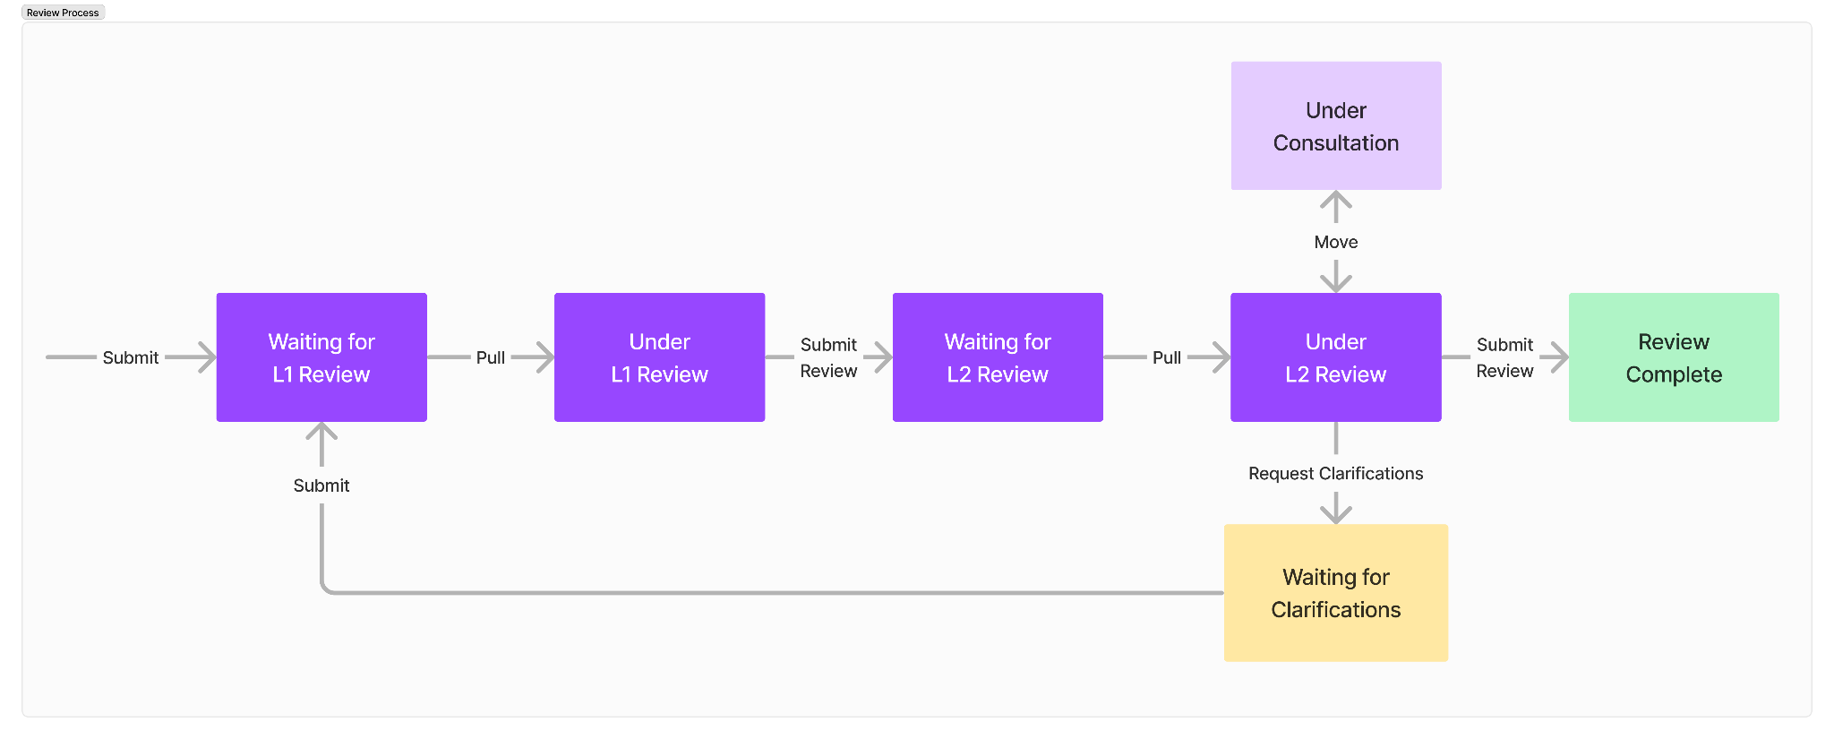

### Types of reviewers

1. Reviewers are experts of the DPG standard. They interpret the standard in context of the DPG objectives and apply them to the applications.
2. Reviewers make and own review decisions on each indicator.
3. The DPG standard covers a lot of ground across technical, legal and other requirements. While each reviewer is good at some indicators, they are hired and trained to develop expertise across all indicators over time.
4. There are two types of reviewer: Level-1 & Level-2
   1. L1 reviewers are experts across *some*indicators. Their indicator-wise expertise is internally known.
   2. L2 reviewers are experts across *most* of the indicators. L2 are typically more experienced than L1 reviewers, however this is not a hard rule.

Note: In the webapp, a reviewer can be either L1 or L2, not both.

### Application flow

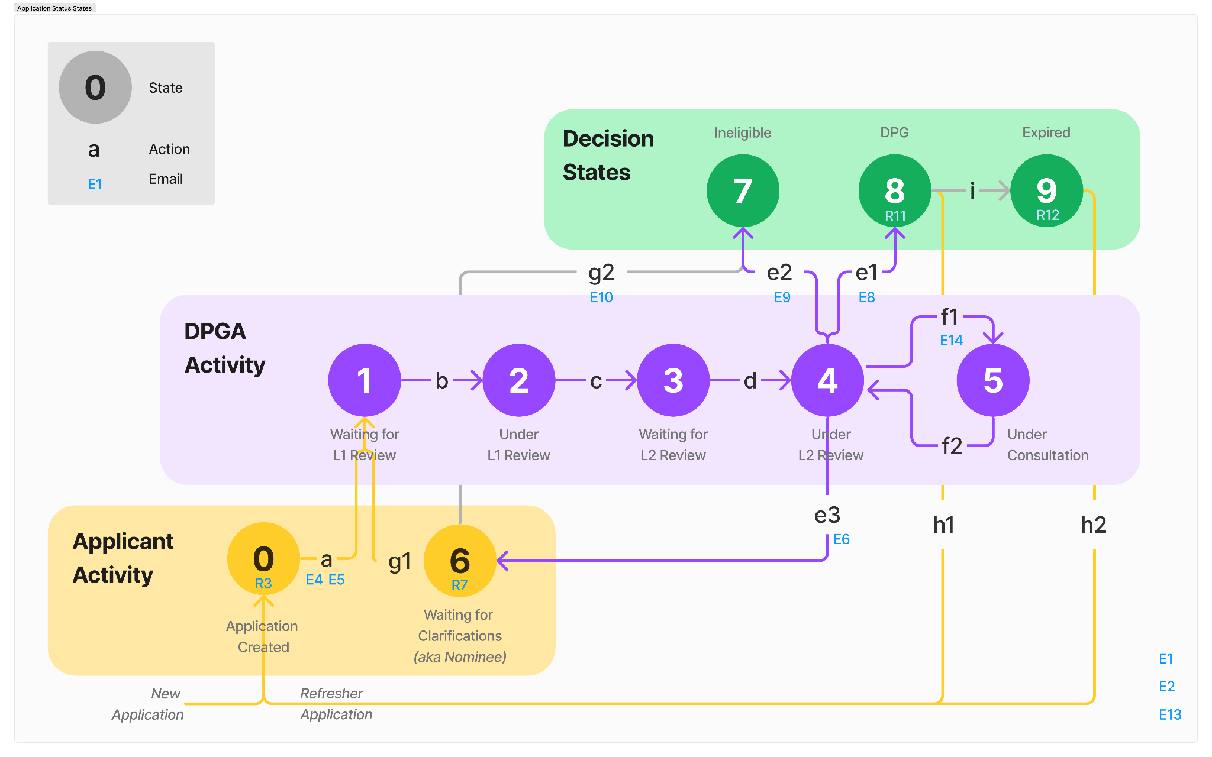

### 

1. There are 10 possible states an application can exist in. Refer to the diagram above.
   * 0 – Application Created
   * 1 – Waiting for L1, aka L1 queue
   * 2 – Under L1 Review
   * 3 – Waiting for L2, aka L2 queue
   * 4 – Under L2 Review
   * 5 – Under Consultation
   * 6 – Waiting for Clarifications aka Nominee
   * 7 – Ineligible
   * 8 – DPG
   * 9 – Expired
2. An application can exist in only one state at a time.
3. All applications in L1 queue are visible to all L1 reviewers
4. All applications in L2 queue are visible to all L2 reviewers
5. When an application is pulled into 2 or 4, or moved into 5, the application will only be visible to the reviewer who pulled it.
6. *DPG* is a temporary state that automatically changes to *Expired* state when:
   * 365 days have passed since last decision, or
   * when a decision has been taken on the refresher application of an application.
7. Every application eventually ends up as either *Ineligible* or *Expired*.
8. An *Ineligible* application cannot be refreshed. Applicants will have to create a new application and try again.
9. State change actions:
   * a. Appl ication is completed and submitted by the applicant.
   * b. Application is pulled under first review by an L1 reviewer.
   * c. Application review is submitted for second review by the L1 reviewer.
   * d. Application is pulled under second review by an L2 reviewer.
   * e1. Application review is completed by the L2 reviewer (all indicators were passed)
   * e2. Application review is completed by the L2 reviewer (one or more indicators were not passed)
   * e3. Request for clarifications is submitted by the L2 reviewer.
   * f1. Application moved to under consultation by L2 reviewer.
   * f2. Application moved back to under review by L2 reviewer.
   * g1. Clarifications are submitted by the applicant
   * g2. Time given to the applicant to respond with clarifications **expires**.
   * h1. A refresher application is created for a DPG (which is expiring soon) by the applicant.
   * h2. A refresher application is created for an expired DPG by the applicant.
   * i. Time for which an application can be a DPG **expires** (1 year)
10. Automated system-generated emails are sent at different steps. Refer [System-generated email templates](https://docs.google.com/document/d/1jZ4rgrZeBpHyFoI94lYyjM7ZB28Cjl7nMHUFl4-tWKE/edit?pli=1#) for more details.

### Types of applications

1. There are two types of applications entering the L1 queue.
   1. New applications – can be created by anyone.
   2. Refresher applications
      1. can only be created for an application with status as *DPG* or *Expired*.
      2. can only be created after 330 days from the date of last decision. (this number is variable that can be set from the admin panel)
2. Each application carries a unique ID.
3. A refresher application will be linked to its parent application.
4. When a decision is made on a refresher application, the status of its parent application is automatically updated to *Expired* to avoid duplication of solutions on the registry.

### Application assignment

1. Reviewers will self-assign applications to themselves.
2. Reviewers will “pull” an application from their queue to “under review” to do this.

Note: Applications will not be auto assigned because (1) this allows for flexibility to choose which application to review based on changing internal priorities and (2) we do not need to develop additional functionality in webapp to account for holidays, weekends, leaves, etc.

SOP for pulling applications under review

1. While reviewers can pull any application, as a standard procedure, they must only pull applications from the top of the queue, unless otherwise instructed by the admin or a senior DPGA member.
2. Applications that re-enter the review pipeline (when an applicant submits clarifications) can be pulled for review by any reviewer. However, it is recommended that the reviewers who previously reviewed that application should be the one pulling it again.

### Managing priority applications

1. A request to review an application on priority can come from
   1. An applicant
   2. A DPGA authorised person
2. Such requests are reviewed & approved/rejected by the DPGA secretariat.
3. When an application is approved to be reviewed on priority, the admin must highlight such applications from their dashboard.
4. Priority applications automatically rise to the top in the queue.

### Review cadence & capacity

1. Reviewers can only have one application “under review” at a time.
2. Reviewers will have **8 hours** to submit their review after pulling an application. This sets the cadence at approximately one review per reviewer per working day.
3. Reviewers must submit their review to be able to pull another application under review.
4. L2 reviewers can have more than one application in “Under Consultation” because it may take a few days before they are able to complete a consultation with experts.

Note: “One application at a time” limit ensures that reviewers give 100% of their focus to the application under review. This also helps avoid any errors that may creep in due continuous context switching when reviewing multiple applications at a time. This is in line with our choice to ensure reliability of review decisions.

### Nominees

1. Nominees are solutions that have potential to become DPGs. They may require some improvements on their technical, documentation, legal or other areas to fully meet the DPG standard.
2. An application is declared a nominee when the L2 reviewer decides the application can become a DPG after making certain clarification on one or more indicators to ensure that it fully complies with the DPG standard.
3. When the L2 reviewer submits their request for clarification from the applicant, the applicant becomes a nominee.
4. While being a nominee, the solution appears on the registry as a nominee.
5. A solution cannot be both nominee and DPG at the same time.

### Requesting clarifications from Nominees

1. The applicant receives an email stating that they have become a nominee and must respond to the request for clarifications.
2. Clarifications can be requested only once per application. In rare cases when more clarifications are required, the reviewer contact must take permission from the DPGA Secretariat for contacting the applicant over email for the same.
3. An amount of time will be given to an applicant to respond to the request for clarification.
4. This is decided by the L2 reviewer at the time of finalising the request and is based on the extent of clarifications requested.
5. The amount of time could be one of these: 15 days, 30 days, 45 days, 60 days or 90 days.
6. If the applicant responds within the time allotted, the application is added back in the L1 queue.
7. If the applicant fails to respond with all requested clarifications within the time allotted to them, then the application will be automatically declared *Ineligible*.

Note: L2 reviewers should not use the request for clarification mechanism to give an opportunity to the applicant to complete their application. Is it to be assumed that the information provided by the applicant is exhaustive and complete.

### Role of experts

* 1. Experts provide their expert opinion only when solicited.
  2. Experts are to be consulted when L2 requires an expert opinion on very specific issues
  3. Only L2 reviewers can decide whether to consult or not.
  4. Experts are not the interpreter of the DPG standard or make decisions on any indicator. Hence, reviewers must not make generic asks like “does this answer meet the standard?”.
  5. Experts cannot be delegated review work.

### Requesting consultation from experts

1. An L2 reviewer will move an application to “Under Consultation” in the webapp and consult by tagging experts on a per-indicator basis.
2. The experts can view the request and respond with their inputs via the webapp.
3. If additional communication is required between the reviewer(s) and the expert(s), it can be carried out off the webapp on:
   1. Slack, by posting message in the <channel name>
   2. GitHub, by posting a comment under the right PR and tagging the expert
   3. Zoom, during the weekly meetings
4. The L2 reviewer may move the application from “Under Consultation” to “Under Review” to continue their review.

### Panel of experts & their expertise

The following experts are available to DPGA reviewers to consult with.

1. Justin – licensing
2. Ivan - platform independence, tech documentation, data extraction, adherence to best practices
3. Steve - Open licensing, SDG relevance and what makes a good code repository because of his vast experience in ICT4D and software development

### Reviewer check-ins

1. To resolve any review delays, all reviewer including experts meet during a biweekly reviewer check-in meeting

### Schedule of alerts

1. Highlight an application if it has been **Under L1 Review** for more than **8 hours.**
2. Highlight an application if it has been **Under L2 Review** for more than **8 hours.**

### Overruling a review decision

WIP

1. A review decision could be challenged by anyone.
2. When challenged, the senior team at DPGA decides whether to conduct a re-review or not.
3. If the re-review is to be conducted, it happens off the webapp.
4. If the decision is changed, the same can be updated in the webapp by the admin.
5. To ensure security and prevent abuse, updating the decision in the webapp will require an additional password only known to the admin.

### Editing applicant answers

Complete

* DPGA reserves the right to edit answers.
* Reviewers have the ability to edit answers while they are reviewing an application.
* Admin have the ability to edit answers at any time.
* If the edit does not alter the intended meaning of the applicant’s answer, then the edit can be made directly. Example of such edits:
  + Grammar corrections
  + Sentence structuring for clarity
  + Editing specific words for consistency across the applicant
  + Fixing a broken link
* If the edit could result in a variation of the original answer that can be construed as different, then <DPGA person> must be consulted,
* For all edits that lead to significantly different answers from the original answer, a written confirmation email from the applicant must be obtained that accepts the suggested changes
* Versioning is not supported so edits are final and can not be reversed (unless re-edited).
* A copy of original answers gets posted to /candidates repo. This can be used to reverse any unintentional edits.
* A log entry is generated for every edit.

### Propagating changes to Standard

WIP

Update on webapp

Update the application google sheet, change version number

Updates to questions and sections on the webapp application form are instant.

Changes does not affect previous applications

### Adding a new section to form

### Adding a new question to the form

Types of questions

1. Select one
2. Search and select one or more
3. Text - short
4. Text - mid
5. Text - long

Question Attributes

1. Question Text
2. Help Text
3. Answer Placeholder
4. Options - applicable only in non-text type questions
5. Order
6. Section the question belongs to

### Migrating a DPG to new database

WIP

To be executed when an “Add DPG” PR is merged on GitHub.

All migrated DPGs - whether via API or manually entry in DB - are identified by <>. This flagging helps remove them from analytics so that past data does not contaminate current review analytics.

SOP:

1. Login as webapp admin
   1. Go to Import Data > Find the new DPG > Click Import
   2. Go to Application List > Search for the DPG > Ensure that it’s there
2. Login as PHP admin
   1. Go to … > Update “Date Reviewed”
3. Go to DPG Import Status sheet
   1. Add a new entry for that DPG including the Date Reviewed
4. Send email to applicant

**Your DPG application for <Solution Name> has been approved as a DPG!**

Hi <Name>,

Congratulations, <Solution Name> has been approved as a digital public good (DPG)!

We are excited to share that it is now listed on the [DPG Registry](https://digitalpublicgoods.net/registry/) in addition to a growing network of catalogs and aggregated lists of digital public goods.

Some housekeeping: The DPG status will be valid for one year. We will send you a reminder to refresh your status. This is to ensure that your solution continues to be in compliance with the latest [Digital Public Goods Standard](https://digitalpublicgoods.net/standard/).

You can track the current status of all your DPG applications by logging at [app.digitalpublicgoods.net](http://app.digitalpublicgoods.net) using your email. We have already created an account for <applicant email>, please go to [Reset Password](https://app.digitalpublicgoods.net/reset) to create a new password.

For many new DPGs, this is an exciting milestone to share with their community. Linked [here](https://docs.google.com/document/d/1ypYG1EPY7_GXxnFwrhPPlXviKNPWOdJPacE0CaUQx6Q/edit?usp=sharing) is a communications guide that can help you announce your DPG status. Included in this email are Jameson and Sarah from our communications team that would be more than happy to support if you have any questions.

You will also be added to our community of product owners, where you can join our community calls and receive an exclusive newsletter connecting you to valuable resources. Please let us know if other colleagues from your organization/project might be interested in being added to the community channels and activities.

We thank you for your interest in supporting digital public goods and look forward to continuing to watch the impact your project will make.

If you have any questions or need additional support, please reach out to me at [ricardo@digitalpublicgoods.net](mailto:ricardo@digitalpublicgoods.net).

Ricardo Miron  
DPGA Community Coordinator

### Admin Dashboard

Section 1 :

This does not include any DPG that was migrated from GitHub.

Section 2 :